Now till last step that is day 3 part 1 to be done

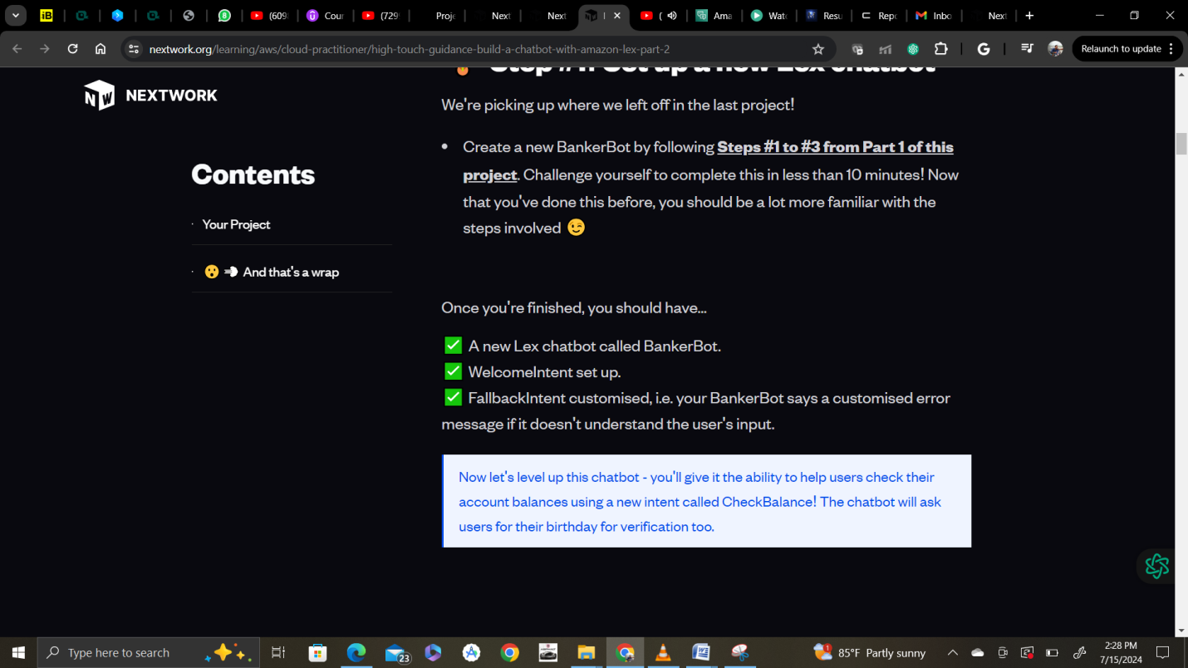

Created successfully.

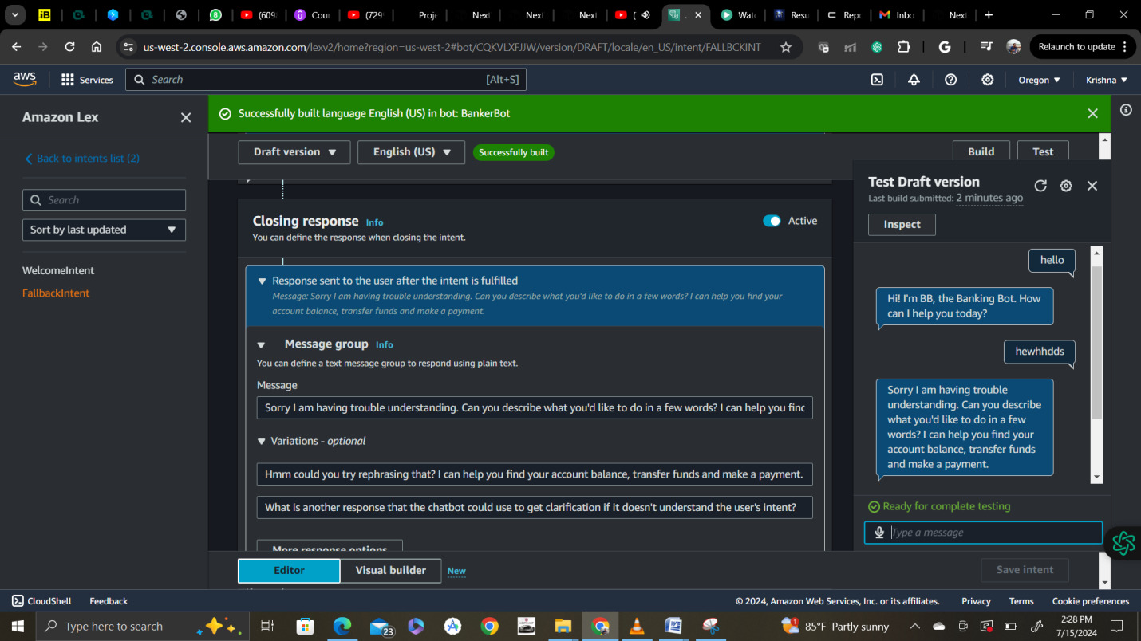

Step 2 :

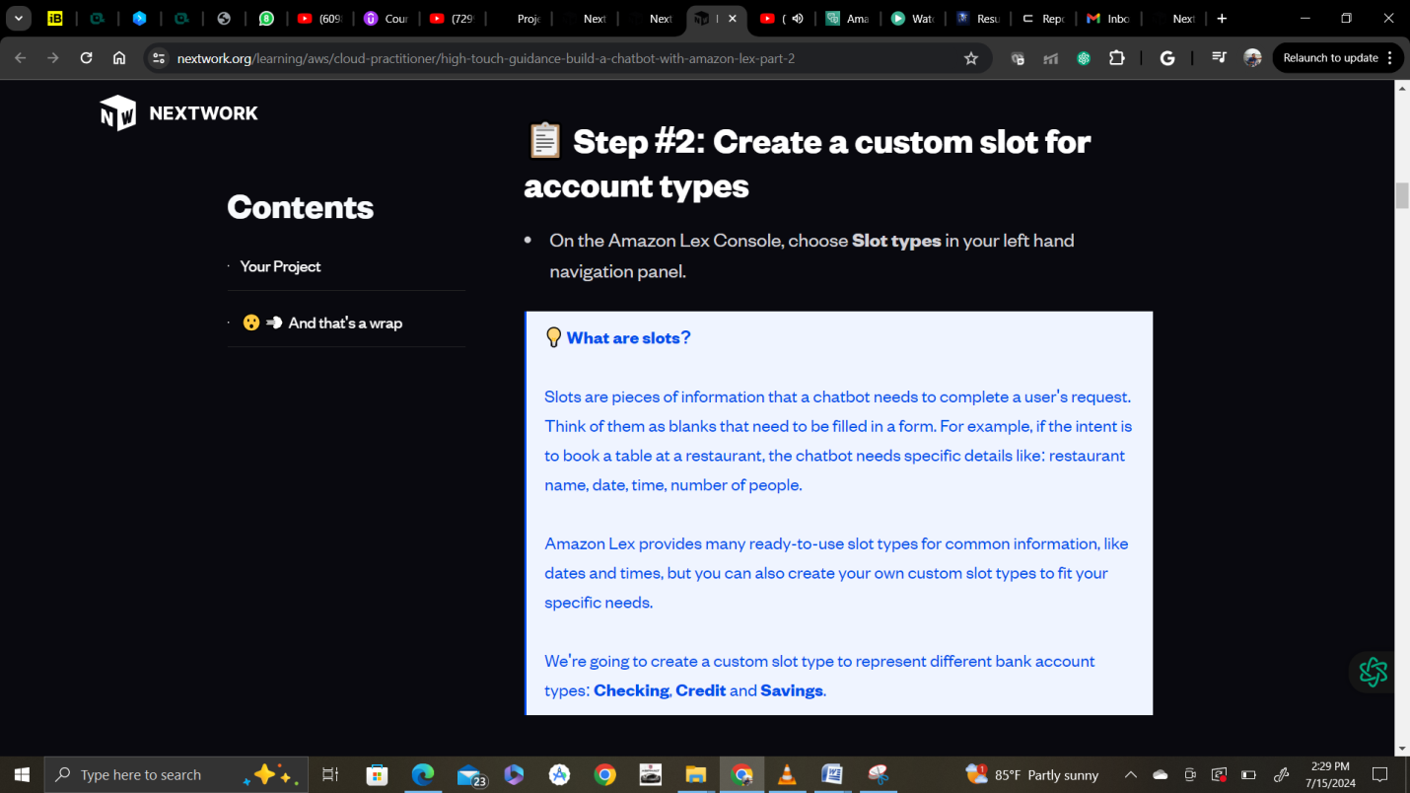

Now select Slot and in drop-down select Add blank slot type option.

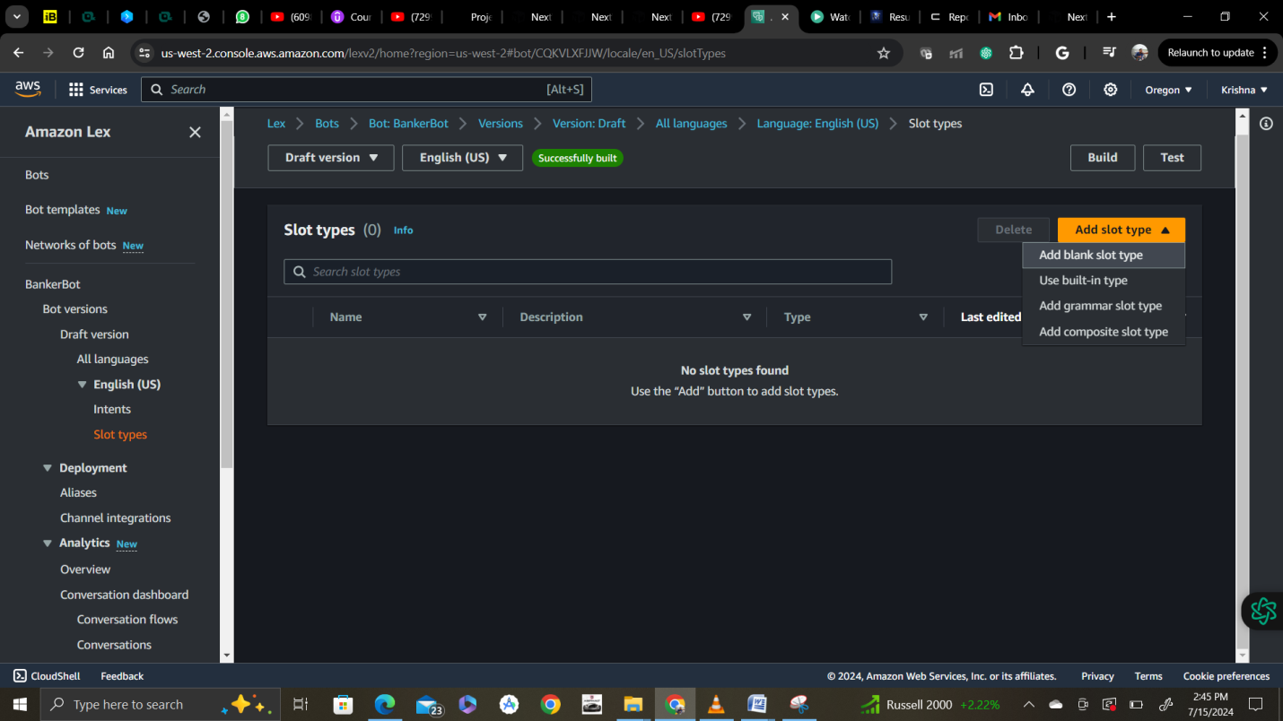

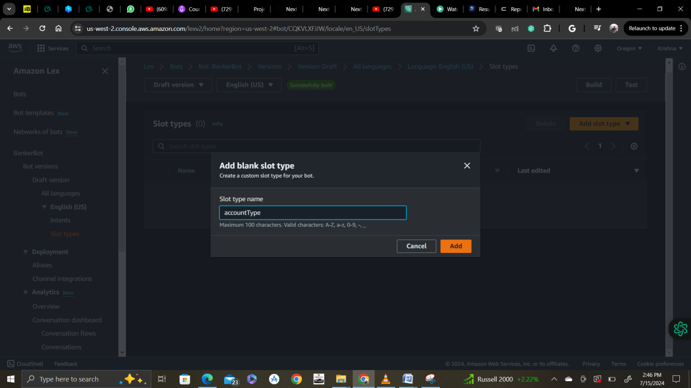

Slot types select restrict to slot values.

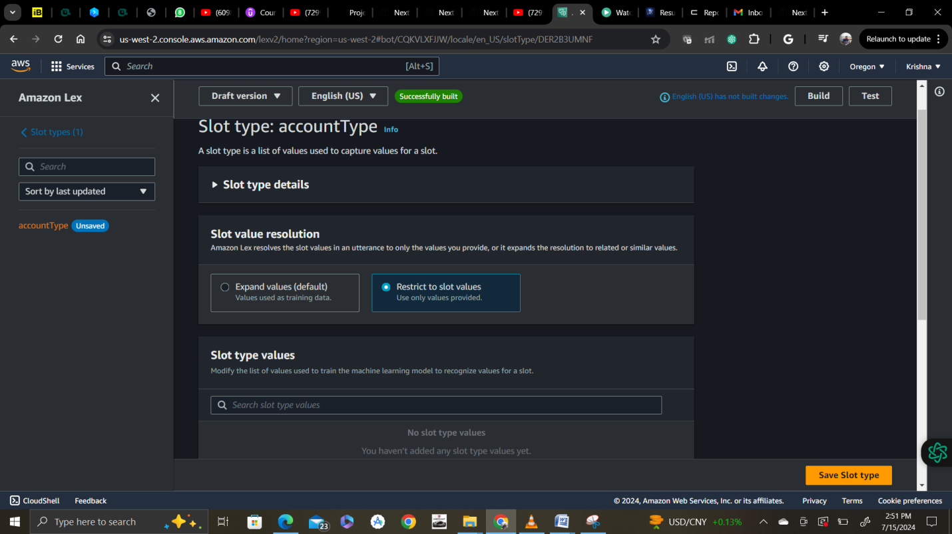

Selecting**Restrict to slot values**makes sure that only the values that you specify will count as a valid accountType! Otherwise, Amazon Lex will use machine learning to accept other values that it sees users constantly entering.  
  
Different use-cases will require different settings, but in our BankerBot we will only offer customers 3 types of accounts - we don't want Amazon Lex to recognise any alternatives.

Add values like this below:

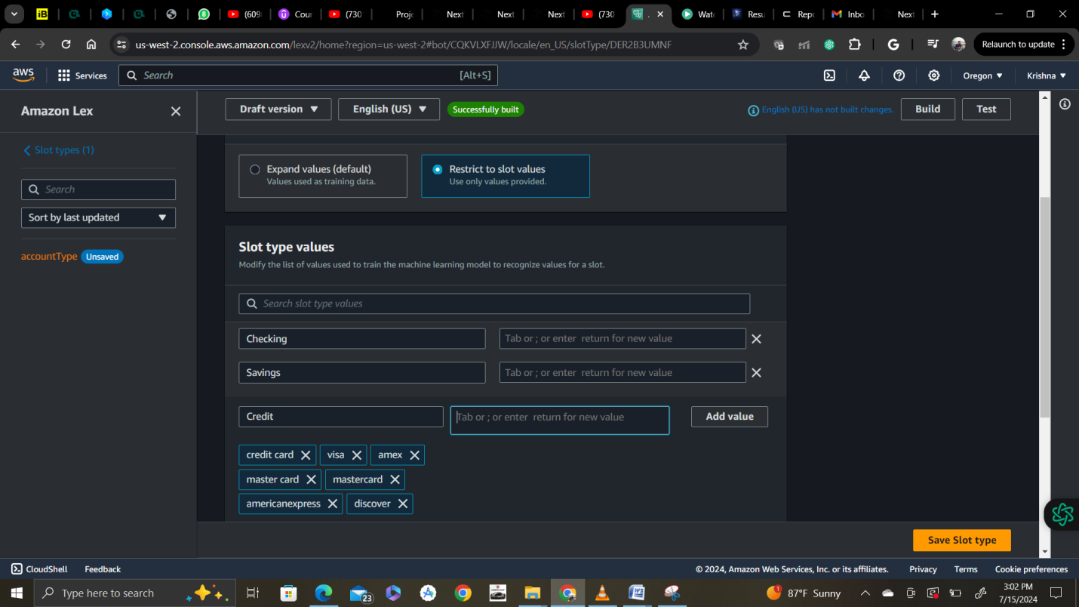

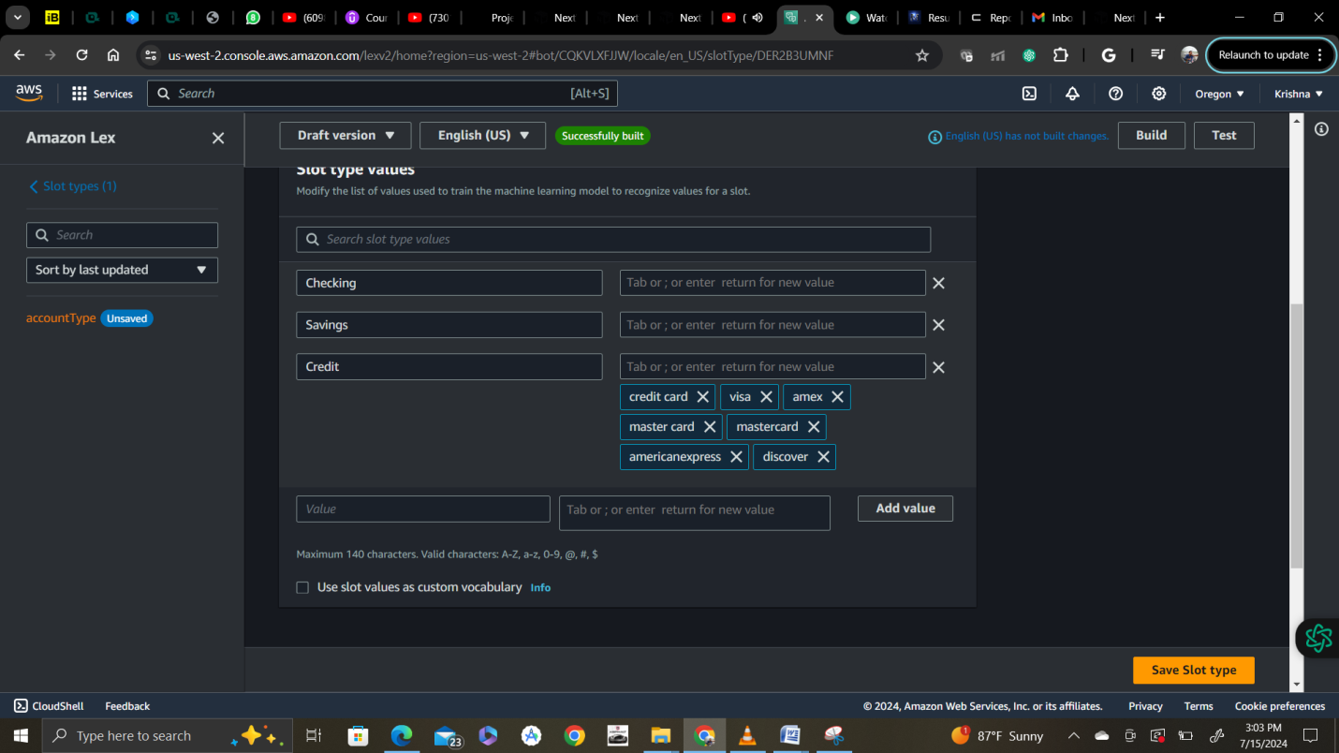

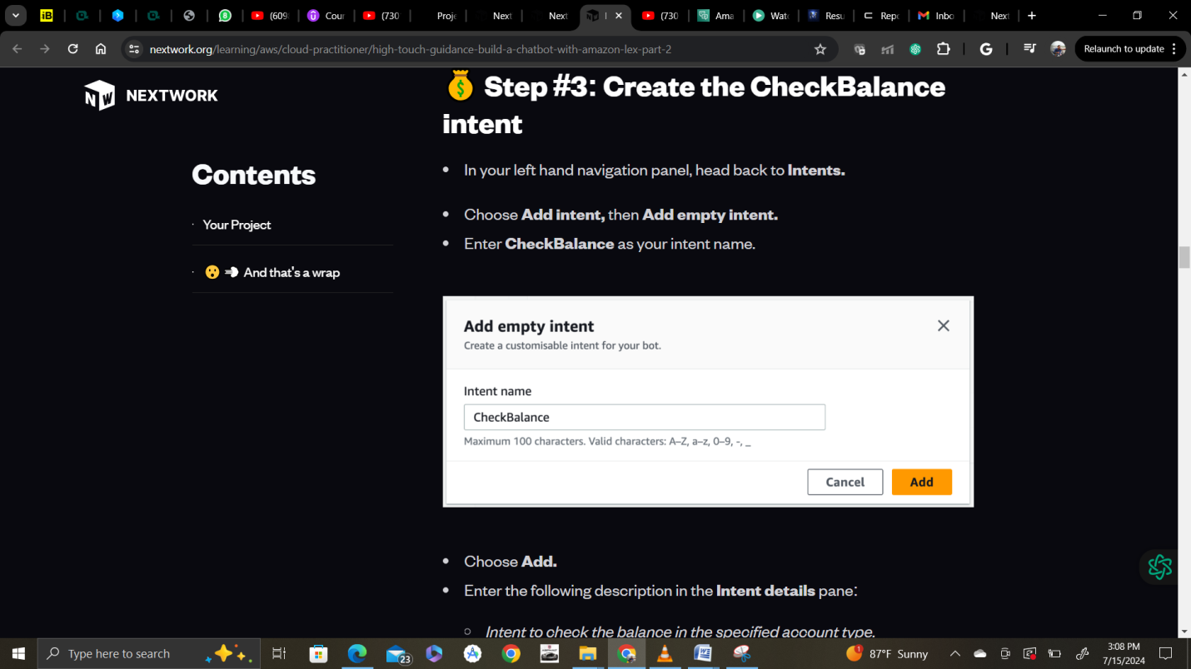

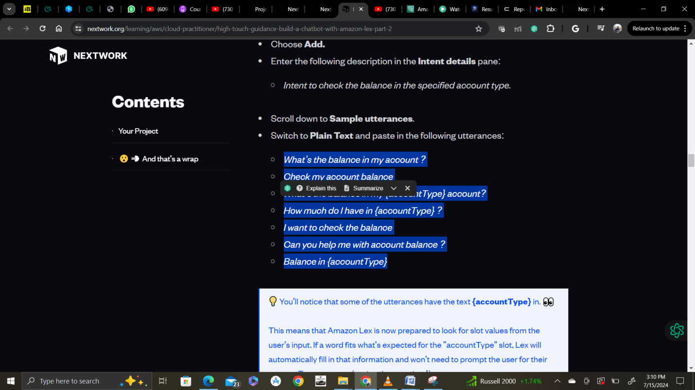

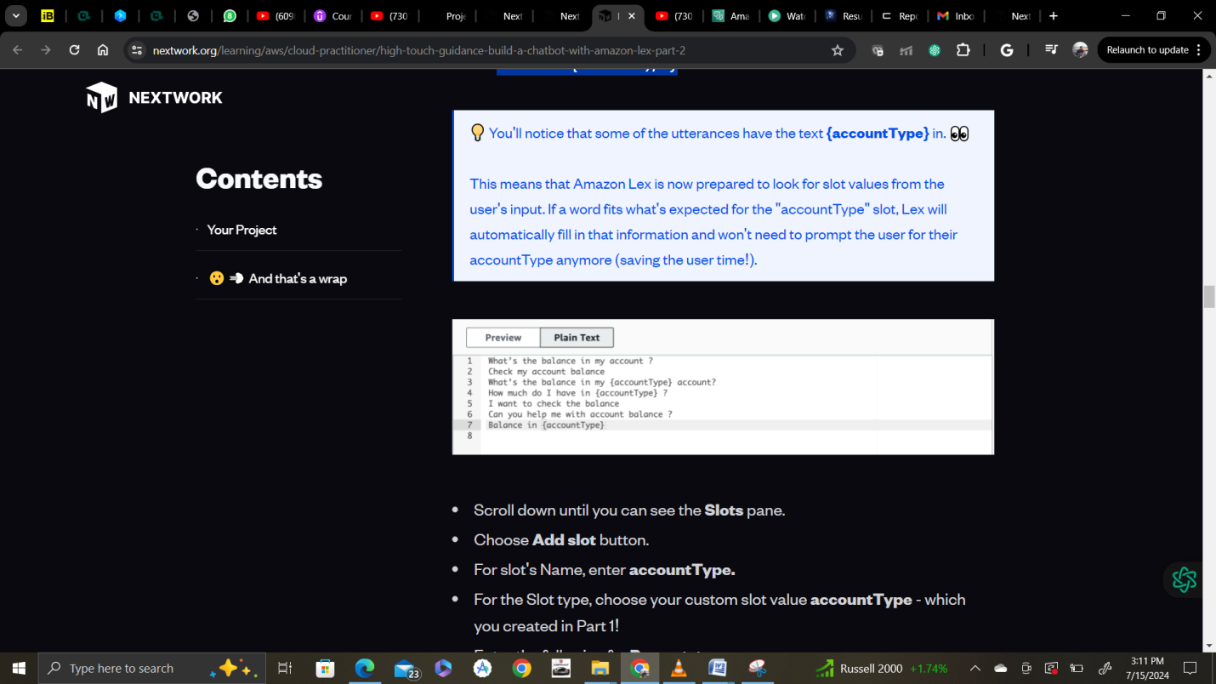

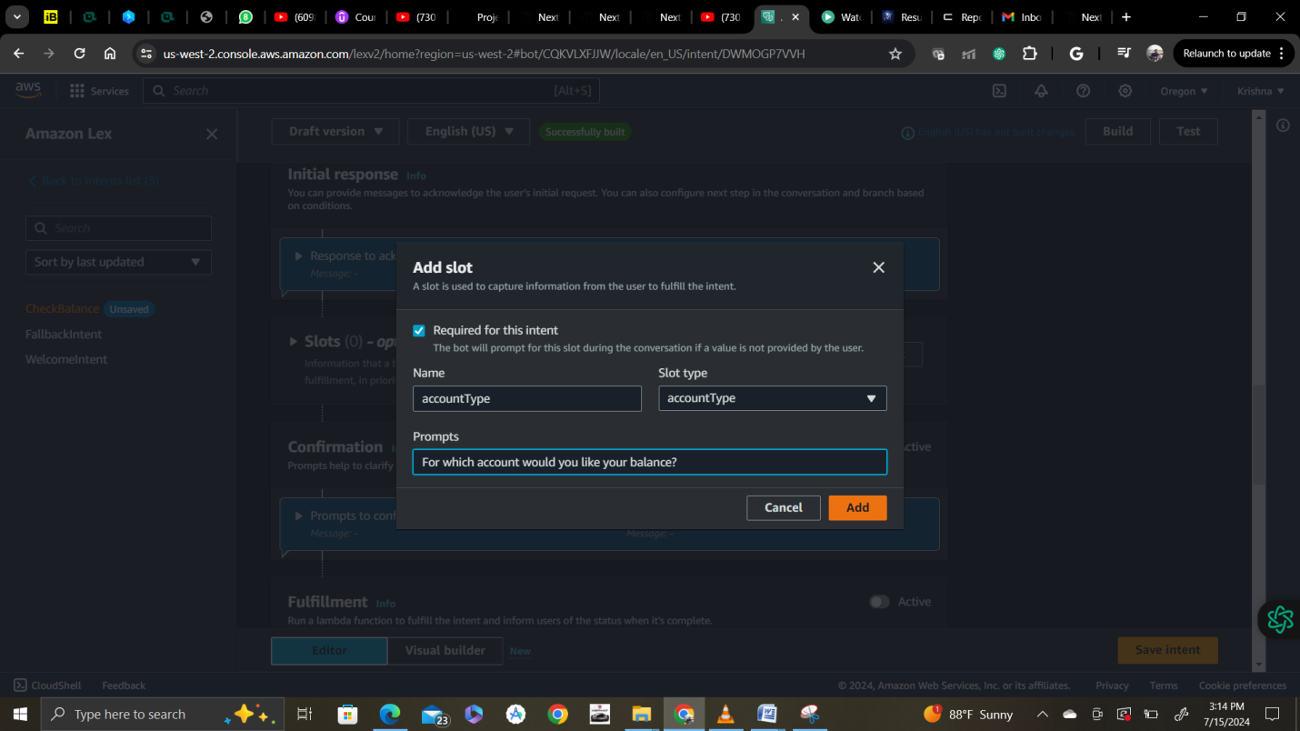

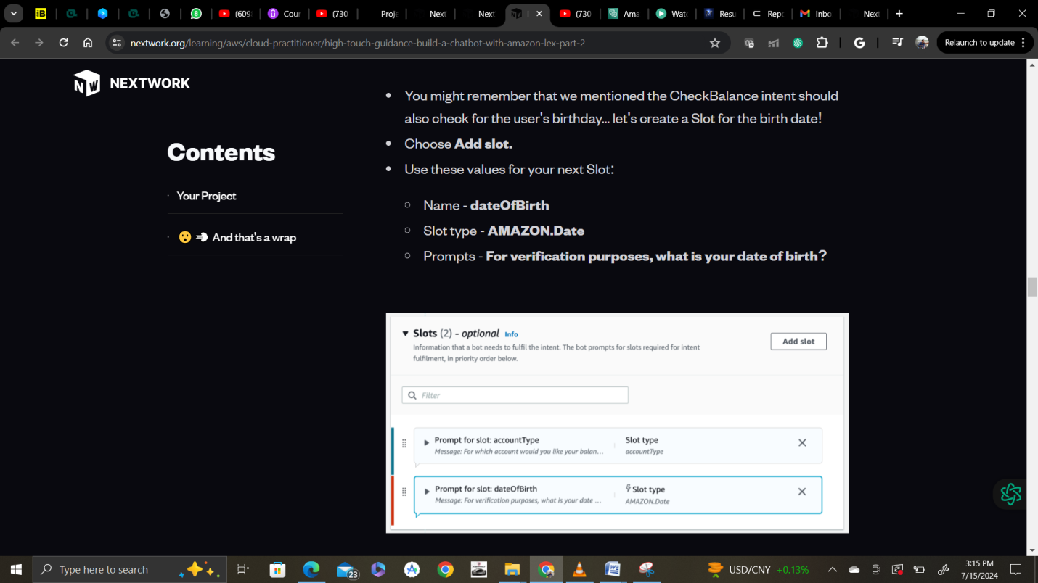

Now create 2nd slot:

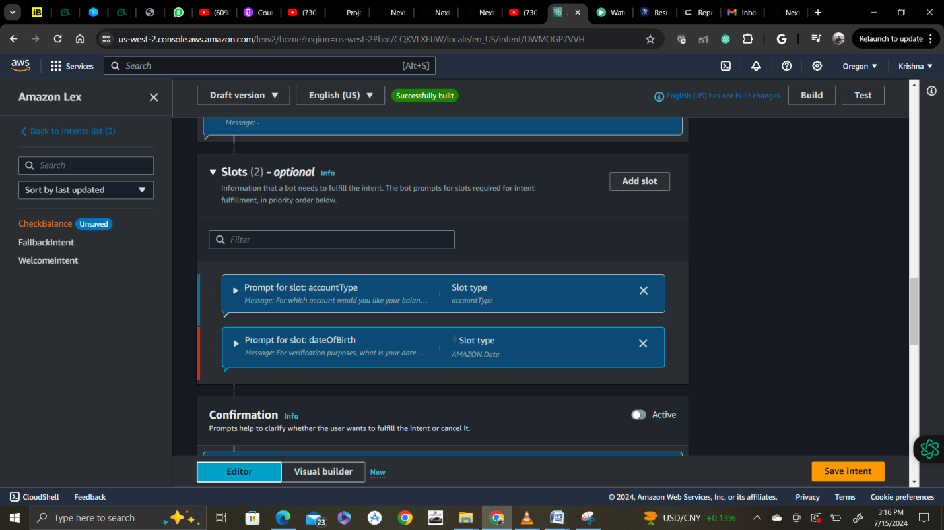

Now you can see that Check Balance intent is also saved

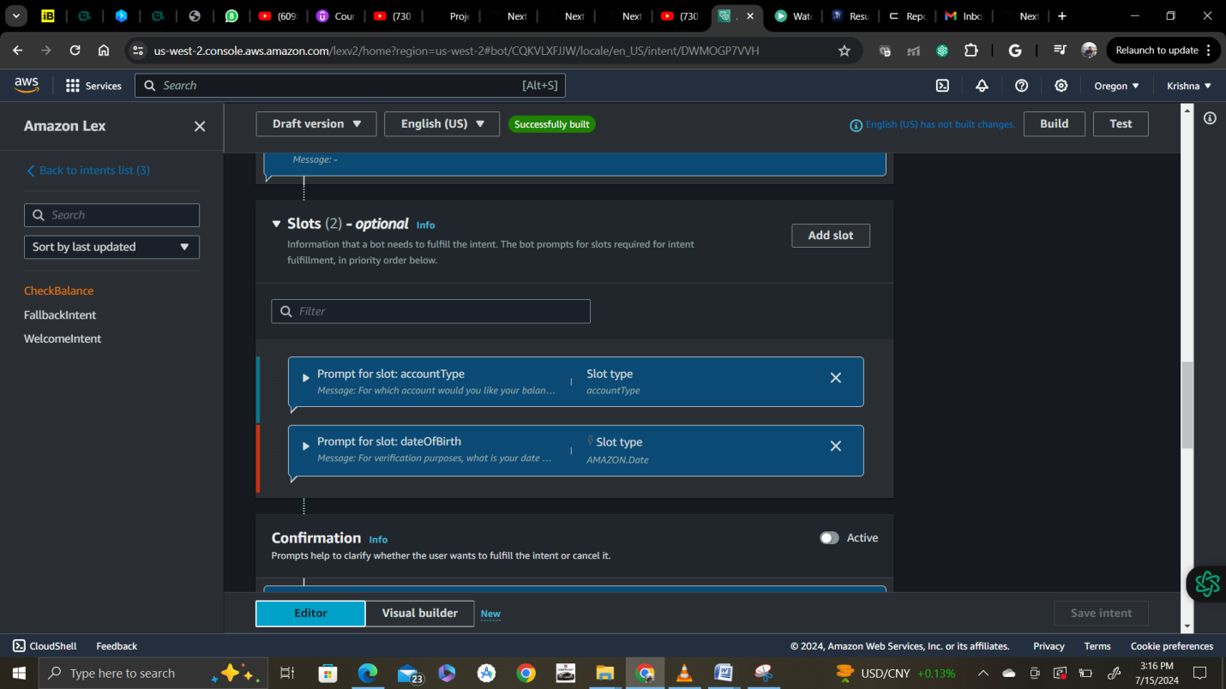

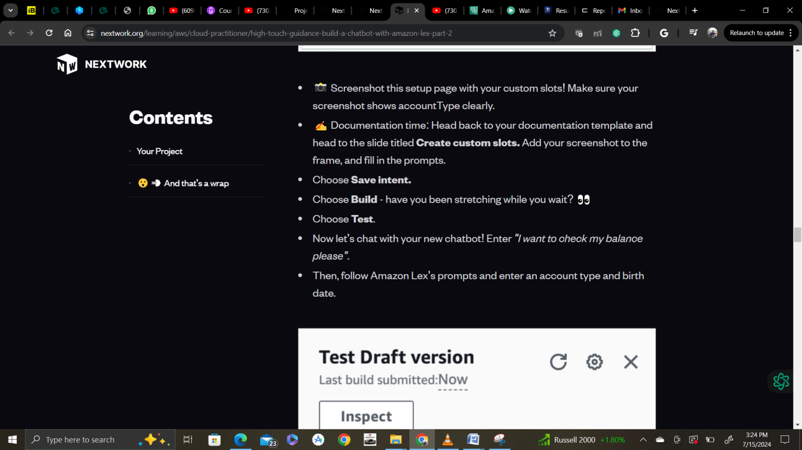

Click on build and after built click on test.

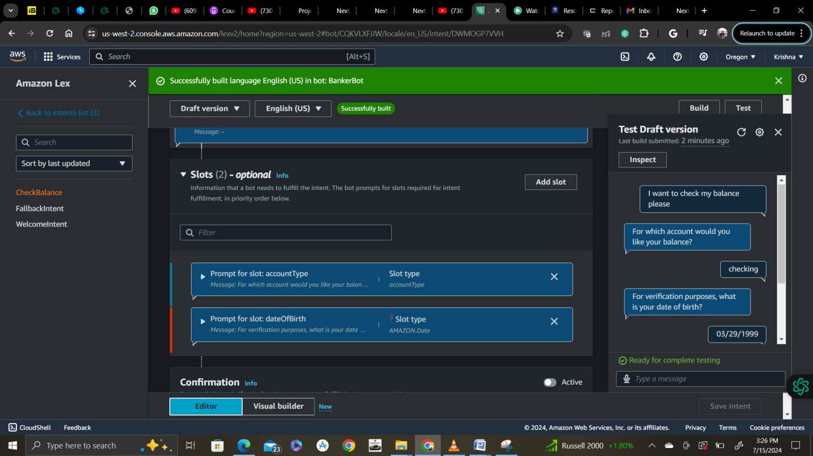

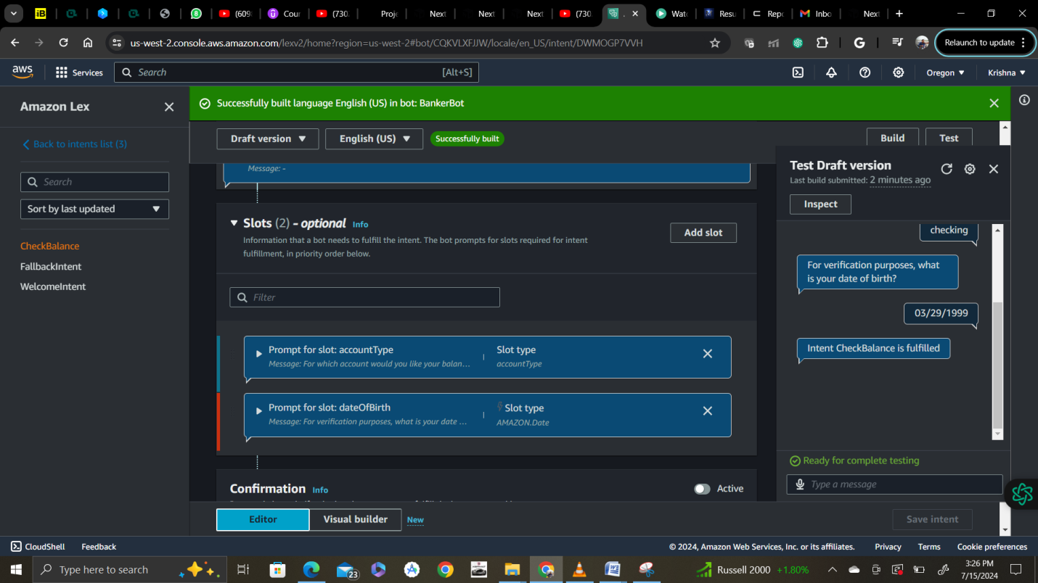

* Now choose **Inspect** near the top of your chat window. Oooo, the chatbot has already filled both slots - accountType and dateOfBirth - with information it now knows about you.

